**Lab 2 – Neural Network – Perceptron Solutions**

1. Consider a neuron with 2 inputs, 1 output, and a threshold activation function. If the two weights are w1 = 1 and w2 = 1, and the bias is b = -1.5, then what is the output for input (0, 0)? What about for inputs (1, 0), (0, 1), and (1, 1)? Draw the discriminant function for this function, and write down its equation. Does it correspond to any particular logic gate? (No coding)

**Ans.**  See last page

1. Work out the Perceptrons that construct logical NOT, NAND, and NOR of their inputs. (No coding)

**Ans.** See last page

1. Study Section 3.4.1. Then prove the same Perceptron Convergence Theorem using ||x|| <= R (instead of using ||x|| <= 1) for some constant R.

**Ans.**

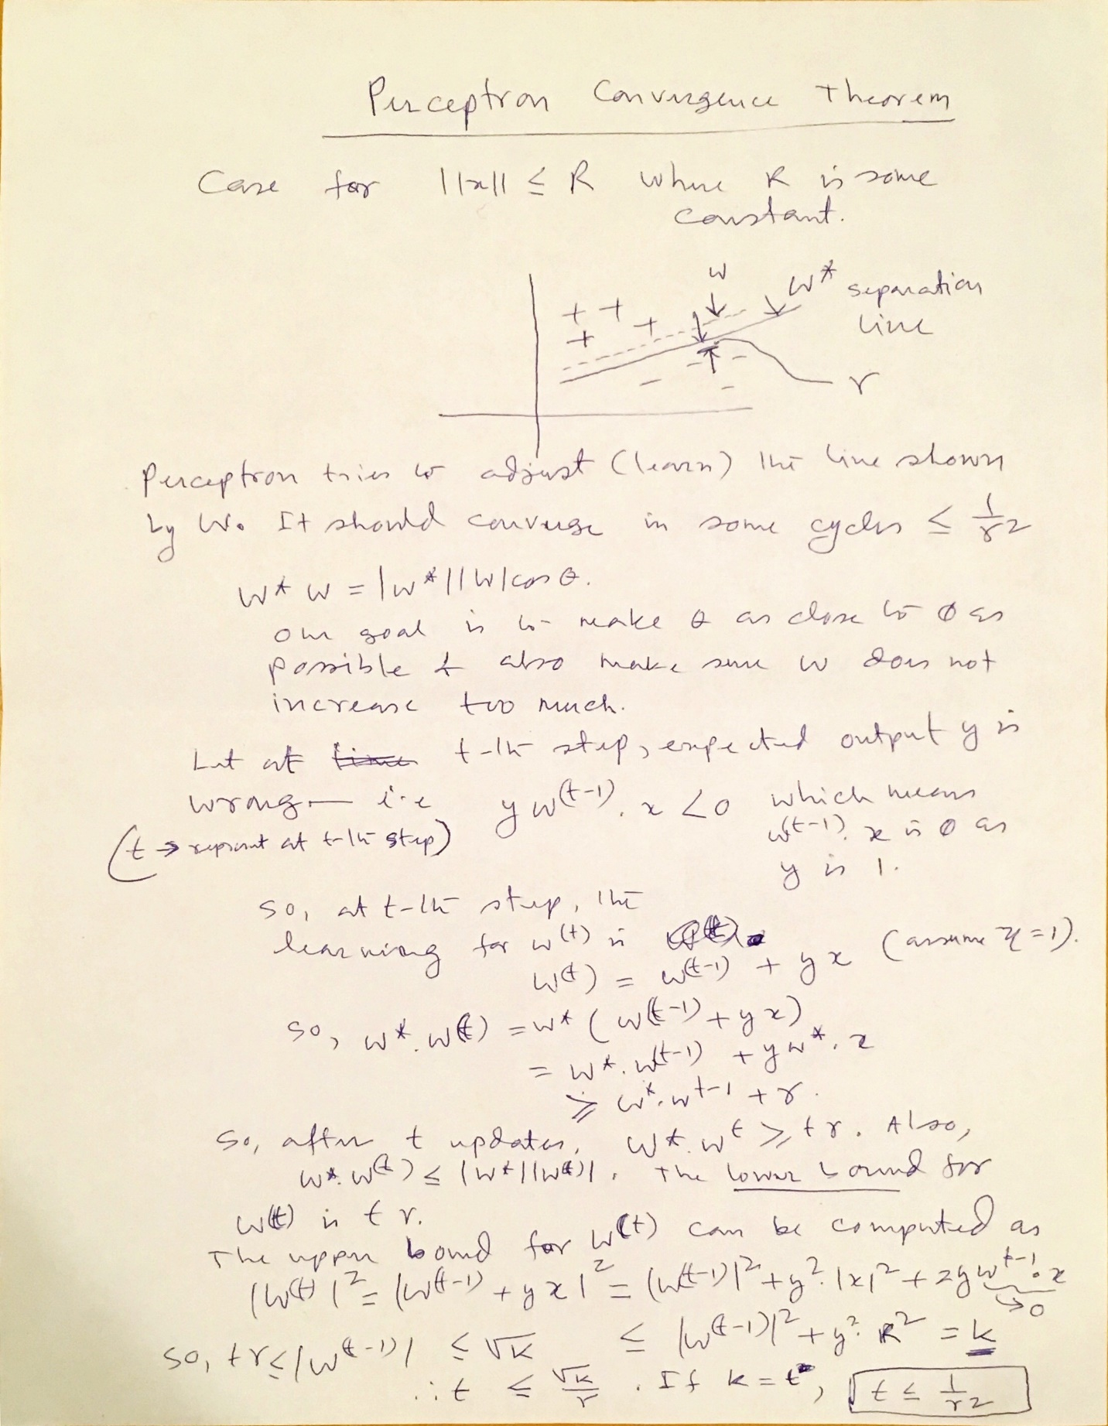

1. The Perceptron code on the website (<http://stephenmonika.net/> ) is a batch update algorithm, where the whole of the dataset is fed in to find the errors, and then the weights are updated afterwards, as is discussed in Section 3.3.5. Convert the code to run as sequential updates and then compare the results of using the two versions. (Modify existing Python program )

Ans. The code is shown below. See the notes carefully. WE have made minimal change to the code by using 1 x m i.e. instead of N x M – this means one input vector at a time:

# Code from Chapter 3 of Machine Learning: An Algorithmic Perspective (2nd Edition)

# by Stephen Marsland (http://stephenmonika.net)

# You are free to use, change, or redistribute the code in any way you wish for

# non-commercial purposes, but please maintain the name of the original author.

# This code comes with no warranty of any kind.

# Stephen Marsland, 2008, 2014

import numpy as np

class pcn:

""" A basic Perceptron (the same pcn.py except with the weights printed

and it does not reorder the inputs)"""

def __init__(self,inputs,targets):

""" Constructor """

# Set up network size

if np.ndim(inputs)>1:

self.nIn = np.shape(inputs)[1]

else:

self.nIn = 1

if np.ndim(targets)>1:

self.nOut = np.shape(targets)[1]

else:

self.nOut = 1

self.nData = np.shape(inputs)[0]

# Initialise network

self.weights = np.random.rand(self.nIn+1,self.nOut)*0.1-0.05

# 11/4/17, 3/3/17 For sequential learning - just assume we are taking one row of the input vector at a time. This way

# the code change will be minimal. Let's call it inputs_inter.

def pcntrain(self,inputs,targets,eta,nIterations):

""" Train the thing """

# Add the inputs that match the bias node

inputs = np.concatenate((inputs,-np.ones((self.nData,1))),axis=1)

# Training

change = list(range(self.nData))

for n in range(nIterations):

print("Iteration: ", n)

for m in range(self.nData):

inputs_seq = np.array([inputs[m]])

targets_seq = np.array([targets[m]])

self.activations = self.pcnfwd(inputs_seq)

self.weights -= eta*np.dot(np.transpose(inputs_seq),(self.activations -targets_seq))

print("Interactive steps m: ", m)

print(self.weights)

print(self.activations)

#return self.weights

def pcnfwd(self,inputs):

""" Run the network forward """

# Compute activations

activations = np.dot(inputs,self.weights)

# Threshold the activations

return np.where(activations>0,1,0)

def confmat(self,inputs,targets):

"""Confusion matrix"""

# Add the inputs that match the bias node

inputs = np.concatenate((inputs,-np.ones((self.nData,1))),axis=1)

outputs = np.dot(inputs,self.weights)

nClasses = np.shape(targets)[1]

if nClasses==1:

nClasses = 2

outputs = np.where(outputs>0,1,0)

else:

# 1-of-N encoding

outputs = np.argmax(outputs,1)

targets = np.argmax(targets,1)

cm = np.zeros((nClasses,nClasses))

for i in range(nClasses):

for j in range(nClasses):

cm[i,j] = np.sum(np.where(outputs==i,1,0)*np.where(targets==j,1,0))

print(cm)

print(np.trace(cm)/np.sum(cm))

1. Study Section 3.4.4. This will give you a good idea about Prime Indian Dataset (<http://archive.ics.uci.edu/ml/datasets.html> - download it), how to plot various parts of it and then using Perceptron to see how well it can classify this data set. You can use the Perceptron code in #4 (or your modified version). This Section has all the key information so that you can run the Perceptron code on the given dataset.

**Run the Perceptron code, analyze the results and write your observation. Show the results – you can submit a plot of the results.**

**NOTE: Pima data set is NO Longer available. You can use other datasets from the UCI archive web site link.**

**But some notes related to Python programming as mentioned in the book in using Pima –**

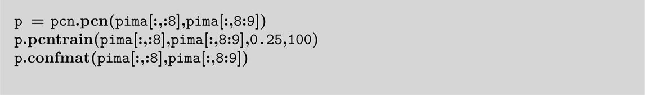

In line 1, pima[:,:8] means All rows and colmns. 0 to 7. Pima[:,8:9] means all rows and just colm. 8 as the target data.

Ans. To Q1 and Q2 –

